VisualFigaro building procedure
under eclipse IDE

Table of contents

1. Development environment 3
2. Choice of a workspace 3
3. New project creation 3
4. External libraries installation 5
5. Source files compilation 7
6. Final file generation: VisualFigaro.jar 8

Development environment

The environment used for development is the Eclipse IDE (version used: Galileo)
« Eclipse IDE for Java Developers » Ref package: eclipse-java-galileo-SR2-win32.zip
Download link: http://www.eclipse.org/downloads/download.php?file=/technology/epp/downloads/release/galileo/SR2/eclipse-java-galileo-SR2-win32.zip

Choice of a workspace
When Eclipse is launched, it prompts for the choice of the directory that will be the current “workspace”.
The chosen workspace does not need to contain the directory where the source code downloaded from Sourceforge (or obtained via another means) is situated.

New project creation

- Select in the menu bar: File->New->Java Project

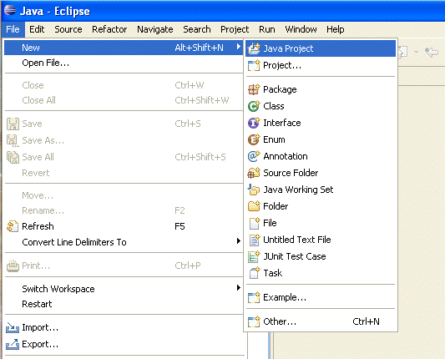

The following window appears:
- Enter the new project name: VisualFigaro
- Select « Create project from existing source » then enter the path access to the VisualFigaro package directory « 1_Sources\src » (field « Directory : »)
- Click on

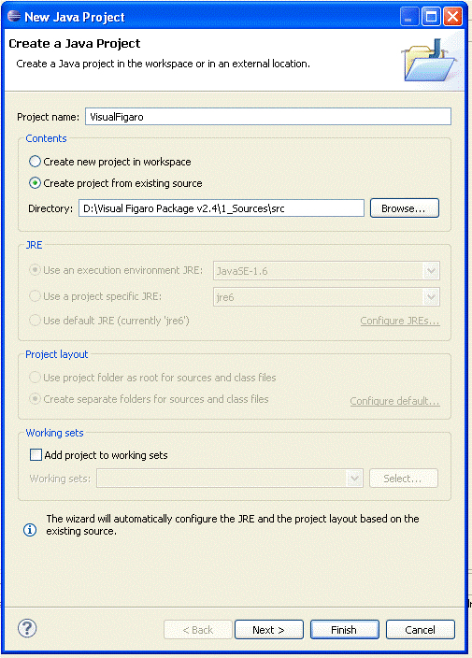

External libraries installation
Within the “Package Explorer” window (Window/Show view/Package Explorer), click on the « + » icon to display the project files and packages:

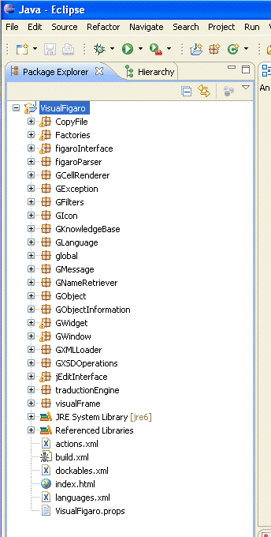

The errors shown are due to missing libraries.
Therefore, we have to install the following external libraries in the « References Libraries » directory: jEdit.jar, log4j-1.2.8.jar, aclibico-2.1.jar et jdom.jar

The corresponding binary files are located in the following directories (these files will not be copied somewhere else: the links are just references to existing files):

Library file | Path
jEdit.jar | C:\Program Files\jEdit **
log4j-1.2.8.jar | Visual Figaro Package\2_Exe\EnglishFrancais
aclibico-2.1.jar | Visual Figaro Package\2_Exe\EnglishFrancais
jdom.jar | Visual Figaro Package\2_Exe\EnglishFrancais

** To access to the « jEdit.jar » file, the jEdit software has to be installed first by using the corresponding installation package.

The installation procedure of libraries is as follows:
  - Right click on project « VisualFigaro » then select the « Properties » item or select « Project->Properties » from the menu bar
  - The following window appears Select « Java Build Path » then the tab « Libraries »
  - Add the defined libraries by clicking on the button :

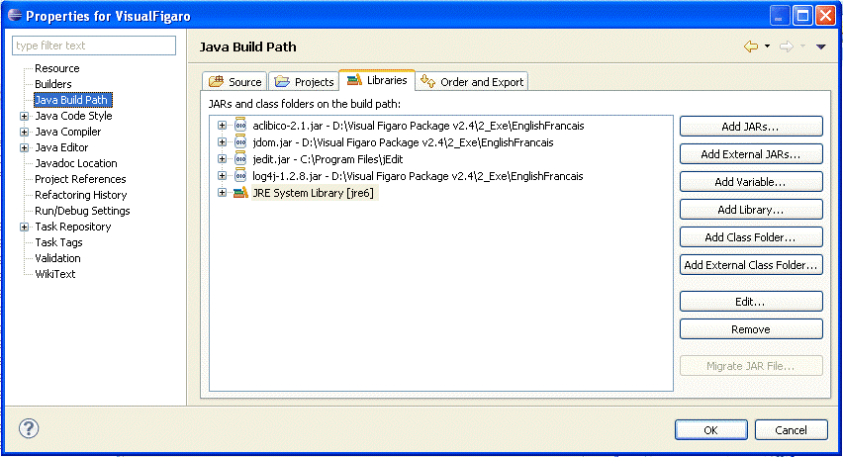

Source files compilation

The option « Project-> Build automatically » is set by default. This option allows generating automatically the project after a command « Project->Clean…» (automatic compilation when a change in a file has been saved).

- Launch the clean command from the menu bar « Project->Clean »

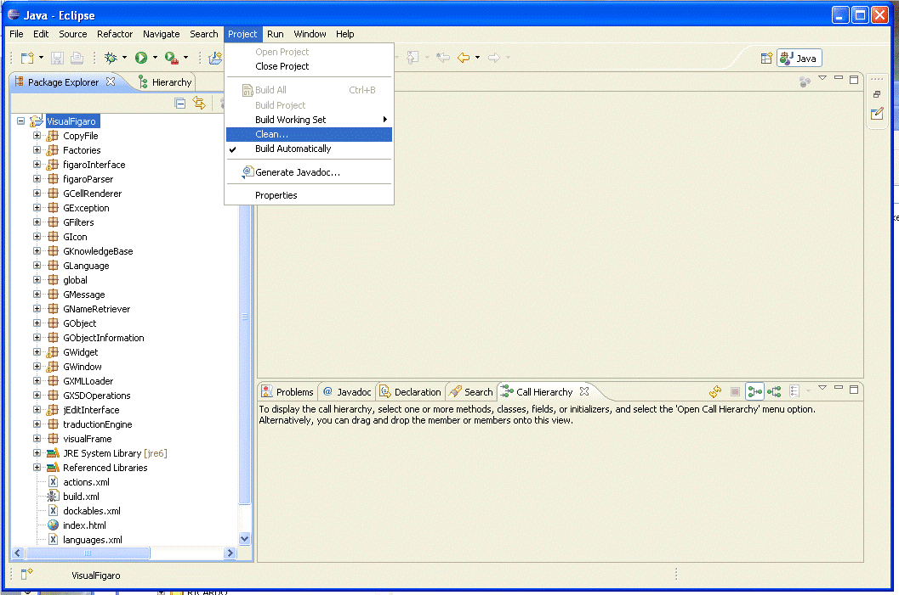

The following window appears:

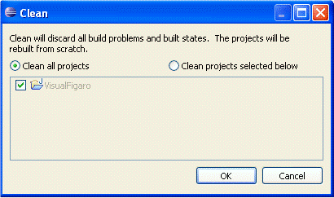

The default option can be kept (Clean all projects): Click on

The eclipse IDE will clean all the previous generated binary files then the Java Builder is automatically launched (java source files compilation). The compilation results are displayed in the « Problems » window located at the bottom of the main IDE window. It should remain no error: « 0 errors ».
By cons it may still remain some warnings.

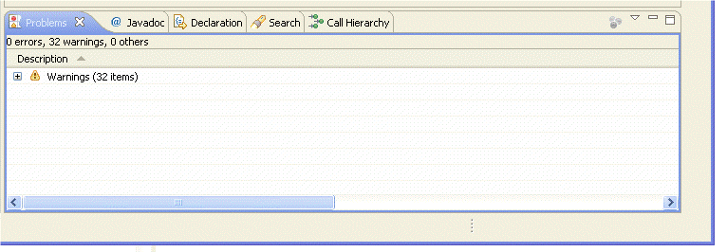

The java source files compilation is completed (binary generation). The next step is to encapsulate the binary files in the .jar container.

Final file generation: VisualFigaro.jar

This step is performed with the « Export » command.

- Select from the menu bar « File-> Export… »

The following window appears:

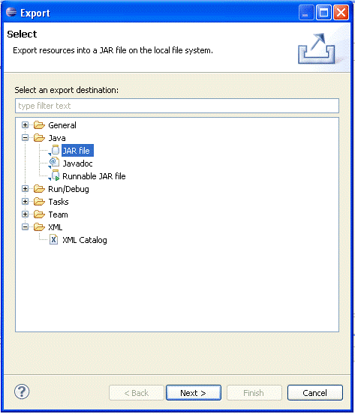

- Click on the « Java » directory then select the« JAR file » format and finally click on the button

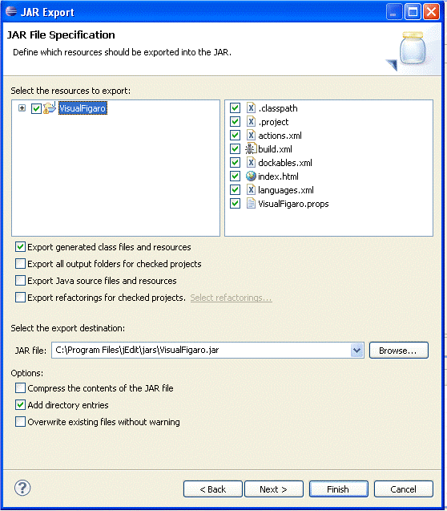The following window appears:

- Check the box « VisualFigaro » The files located in the right window should be checked too.
- Select the option « Export generated class files and resources ».
- Finally enter the name and the path where you want to store the .jar file (field « JAR file: »).
- Click on : an overwriting confirmation window will appear if the specified file already exists in the defined location. Finally if there were remaining warnings, one last reminder window notifies you that the file contains warnings click on "ok". The generation is completed.

